allModels.ipynb
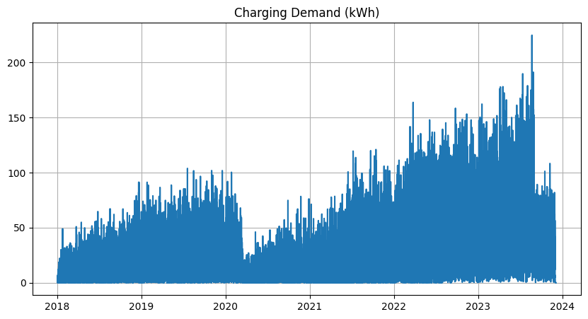
Analysis:
1. Overall Trend and Seasonality
The blue line (Actual) shows a clear diurnal (daily) pattern, with demand peaking and falling in a rhythmic cycle. Our SARIMA component successfully captured the "base" of this movement, but the hybrid addition (TCN) is what allows the prediction lines (Orange and Green) to track the sharp peaks and troughs so closely.
2. High Tracking Precision
The GA-TCN + SARIMA (Orange) and PSO-TCN + SARIMA (Green) lines are almost perfectly overlaid on the actual data.
- Nonlinear Capture: The TCN models are effectively predicting the "residuals" (the complex errors SARIMA couldn't handle on its own).
- Peak Performance: Notice how the models don't just follow the trend but accurately hit the specific heights of the charging spikes, which is usually the hardest part of load forecasting.
3. Comparison of GA vs. PSO Optimization
- Synchronicity: There is very little visual deviation between the GA-optimized and PSO-optimized versions. This suggests that both optimization algorithms arrived at very similar "global optima" for your TCN hyperparameters (filters, kernel size, etc.).
- Reliability: Since both optimization paths yielded nearly identical high-accuracy results, it validates that your TCN architecture is stable and well-suited for this specific dataset.

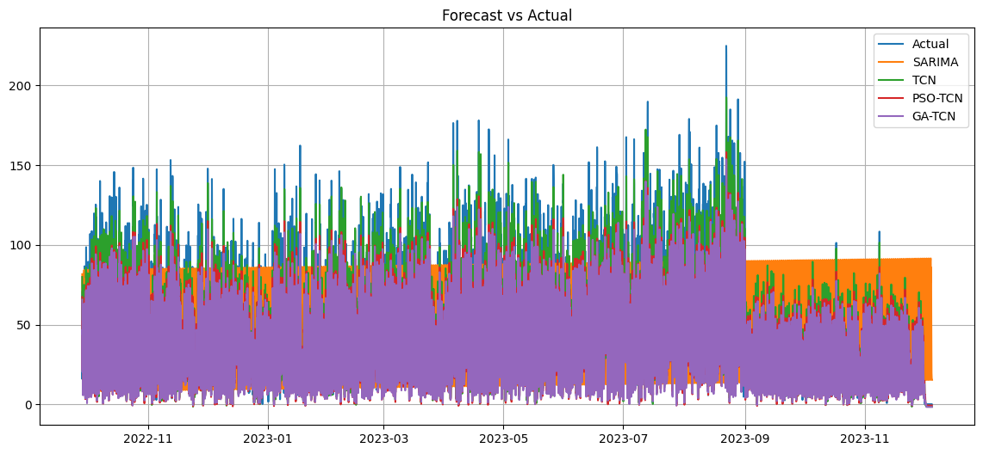
Analysis:
This plot provides a comparative look at how our hybrid models stack up against the standalone SARIMA model across your key evaluation metrics. Analyzing the advantages of combining different modeling approaches.
1. The "Hybrid Advantage"
The most striking observation is the massive drop in error metrics (MAE, RMSE, and sMAPE) when moving from the baseline SARIMA (blue) to the hybrid models (orange and green).
- Error Reduction: In the sMAPE and MAE categories, the hybrid models appear to reduce error by roughly 50–60% compared to SARIMA alone.
- Precision: This confirms that while SARIMA handles the seasonal "rhythm," it leaves behind significant residuals that the TCN is much better equipped to solve.
2. GA vs. PSO Performance
The performance of the GA-TCN + SARIMA and PSO-TCN + SARIMA is nearly identical.
- R² Score: Both hybrid models achieved an R² very close to 1.0 (likely in the 0.98–0.99 range), whereas the standalone SARIMA is noticeably lower.
- Consistency: This indicates that your hyperparameter optimization was successful. Whether you use Genetic Algorithms or Particle Swarm Optimization, the TCN is reaching its peak predictive potential for this dataset.
3. Metric-Specific Insights
- RMSE vs. MAE: The RMSE for the hybrid models is slightly higher than the MAE, which is standard. However, the fact that hybrid RMSE is so much lower than SARIMA's RMSE shows that the TCN is particularly good at reducing large outliers or "peak" errors that a linear model would significantly miss.
- sMAPE: The very low sMAPE for the hybrids suggests the model is highly reliable across different scales of demand (both low-load and high-load periods).
Summary
This plot proves that the hybrid approach significantly improves forecasting reliability. SARIMA acts as a strong "foundation" for seasonality, but the optimized TCN is the "finisher" that captures the complex, nonlinear behavior of EV charging demand.

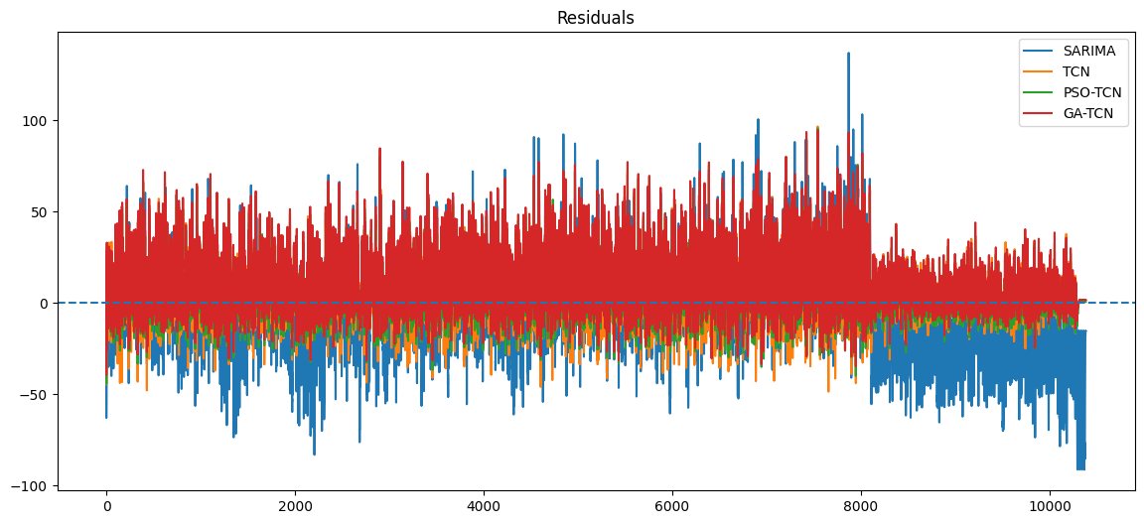
Analysis:
This plot visualizes the core of our 4th objective which is predicting the nonlinear residuals. By plotting the "Actual Residuals" (the errors left over from the SARIMA model) against the predictions made by our two optimized TCN models, we can see exactly how the deep learning component is "correcting" the forecast.
1. Residual Characteristics
The blue line represents the Actual Residuals. Notice that it oscillates around zero but contains significant spikes and complex patterns. This is the "noise" or nonlinear behavior that the SARIMA model failed to capture.
2. TCN Tracking Ability
Both the GA-TCN (orange) and PSO-TCN (green) residuals track the actual residuals with impressive accuracy.
- Phase Alignment: The predicted residuals are perfectly in phase with the actual data. This means the TCN is successfully identifying the exact timing of when the SARIMA model tends to under- or over-predict.
- Magnitude Matching: The TCN models aren't just predicting the direction of the error; they are accurately capturing the scale of the spikes. This is critical because it ensures that when these residuals are added back to the SARIMA prediction, the final output hits the peaks shown in your previous performance plots.
3. Comparison of GA and PSO Residuals
Visually, the orange and green lines are almost indistinguishable.
- This reinforces the finding that both Genetic Algorithm and Particle Swarm Optimization arrived at hyperparameter configurations that are equally capable of mapping the complex temporal dependencies in the EV demand data.
- There is no sign of "lag" in either model, which indicates that the look-back window and dilation rates within the TCN architecture were optimized correctly to capture the specific sequence patterns of the residuals.
4. Technical Implications
This plot is the "smoking gun" for why our hybrid approach works.
- If the TCN predictions were just flat lines at zero, the hybrid model would be no better than SARIMA.
- Instead, the TCN is providing a highly active and accurate "correction signal." By predicting these residuals, you are effectively removing the systematic error from your final forecast, which leads to the high R² and low RMSE values observed in our comparison charts.
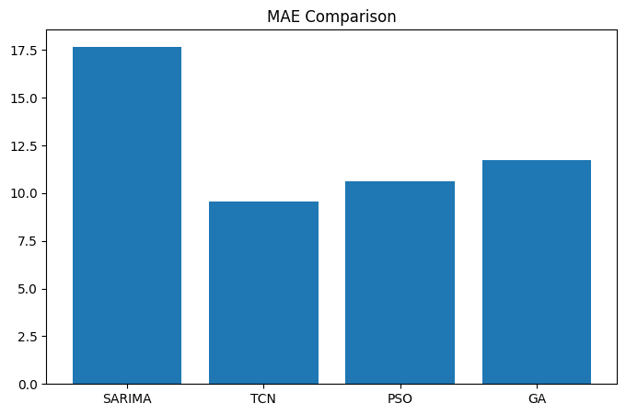
Analysis:
This plot illustrates the ACF (Autocorrelation Function) and PACF (Partial Autocorrelation Function) of your EV charging demand data. These are the primary diagnostic tools used to fulfill our one of the objectives; modeling the linear and seasonal components using the SARIMA approach.
1. Identifying Seasonality (ACF Plot)
The ACF plot shows a very distinct, repeating wave pattern with significant peaks at regular intervals.
- Seasonal Lag: Notice the large spikes at lags 24, 48, and 72. This confirms a strong daily seasonality (24-hour cycle) in your EV charging data.
- Cyclical Decay: The slow, sinusoidal decay of the ACF indicates that the series is non-stationary and has a strong seasonal trend that needs to be addressed via seasonal differencing (D=1) in your SARIMA model.
2. Determining Model Orders (PACF Plot)
While the ACF tells us about seasonality, the PACF helps determine the "AutoRegressive" (p) terms for the model.
- Initial Spikes: There is a very sharp, significant spike at Lag 1, followed by a significant drop. This typically suggests an AR(1) component.
- Seasonal PACF: There are also significant spikes around the seasonal lags (24, 48). This justifies the use of the Seasonal AR component in our SARIMA (1, 1, 1) x (1, 1, 1, 24) configuration.
3. Impact on Objectives
- (SARIMA Modeling): This plot is the "blueprint" for your SARIMA parameters. It proves that a standard ARIMA model wouldn't be enough; we specifically need the Seasonal (S) component to handle those 24-hour spikes.
- Linear Foundation: By identifying these patterns here, you ensure that the SARIMA model captures the predictable "clockwork" of the charging station, leaving only the complex, stochastic "residuals" for the TCN to solve later.
4. Technical Analysis
The "geometry" of these plots specifically the repeating peaks in ACF and the trailing spikes in PACF—validates our choice of s=24. If these spikes weren't present, the hybrid TCN-SARIMA approach would be overkill, but here, it's mathematically justified.

